Assignment: AWS Lambda Function for Monitoring S3 File Uploads

**Objective:** Develop an AWS Lambda function that is triggered by file upload events from an Amazon S3 bucket. The function should examine the size of the uploaded file, and if the file size exceeds 100MB, it should log an alert. This assignment aims to familiarize students with AWS Lambda, Amazon S3, event-driven architecture, and basic logging practices.

1. ● S3 Bucket Setup ○ Create a new Amazon S3 bucket in your AWS account. Take note of the bucket name, as it will be needed later. ○ Ensure the bucket is configured to log access requests for auditing purposes.
2. First create S3 bucket and create it
3. 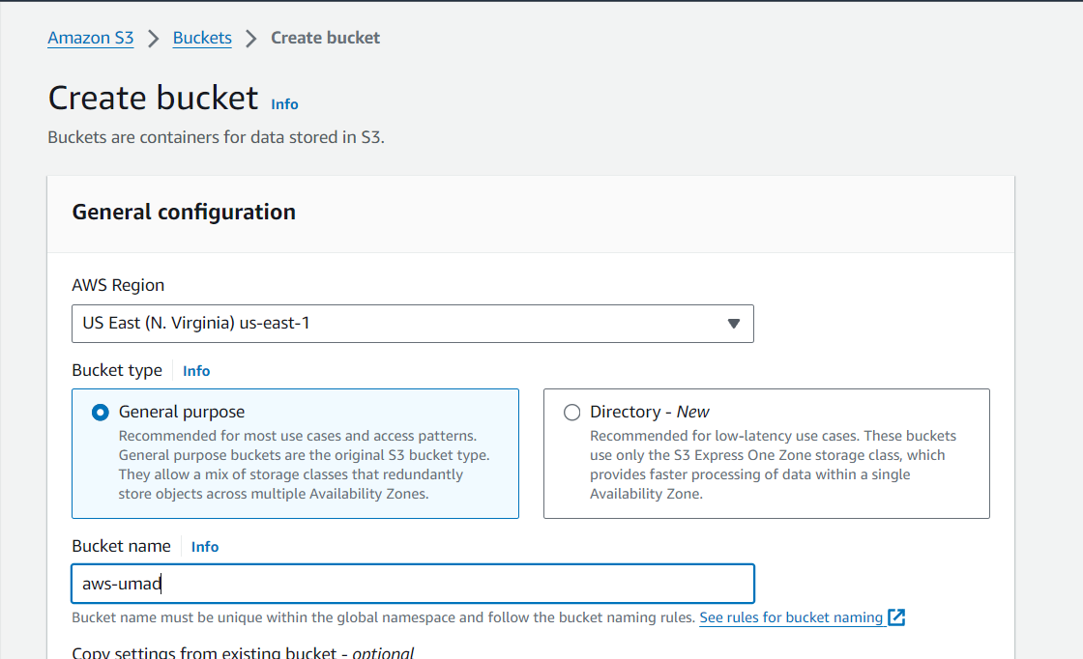

Bucket and lambda function region should be same

1. Next
2. ● IAM Role Creation ○ Create a new IAM role that the Lambda function will assume. This role must have permissions to access S3 data and write logs to Amazon CloudWatch.
3. Will create IAM Role and attach required policies such as -> S3 Full Access and Cloudwatch logs
4. 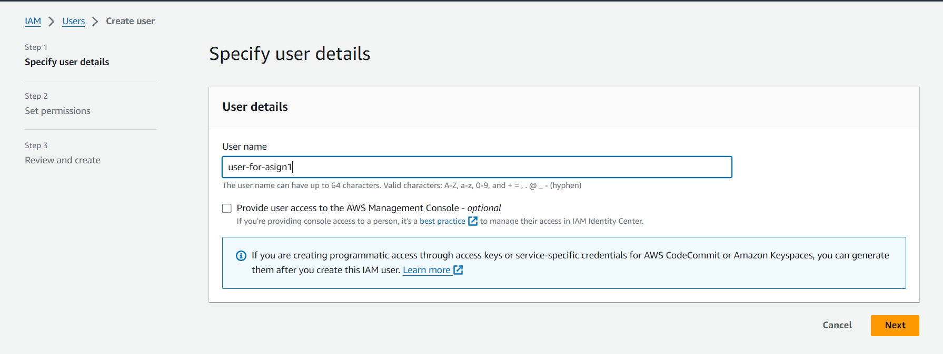

Select Attach policies and search and Add required below in permission policies

1. 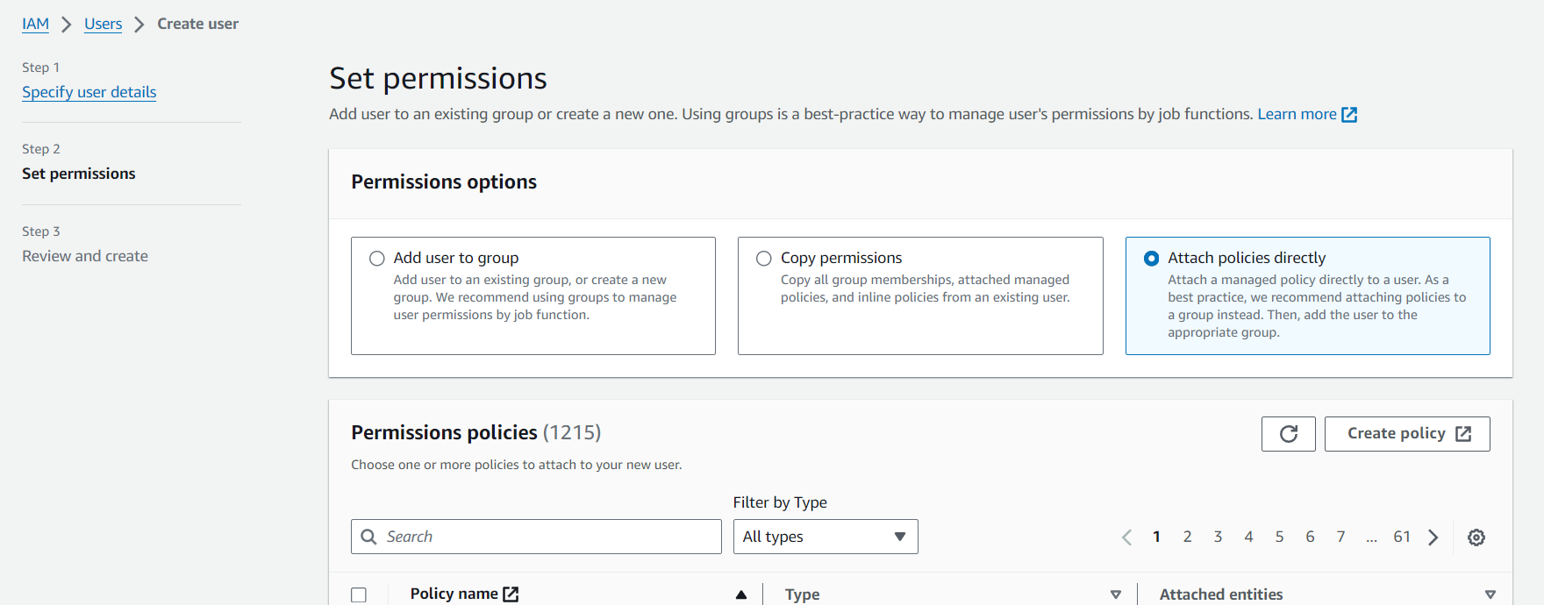

We have added below permissions

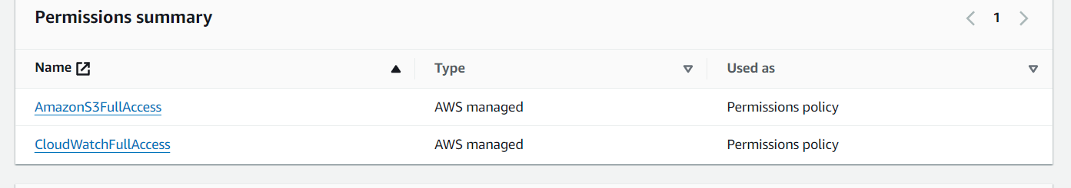

1. Next will create lambda function as per requirement below

Lambda Function Development

○ Create a new AWS Lambda function from the AWS Management Console.

○ Assign it the IAM role created in the previous step. .Set the runtime to Python 3.8 or any other preferred runtime that supports S3 event processing.

○ The function should be triggered by S3 upload events. Configure the trigger appropriately within the Lambda function settings.

○ Write the Lambda function code to:

■ Be triggered upon file uploads to the specified S3 bucket.

■ Retrieve the size of the uploaded file.

■ Compare the file size against the 100MB threshold.

■ Log an alert message if the file exceeds the threshold

Created a function below

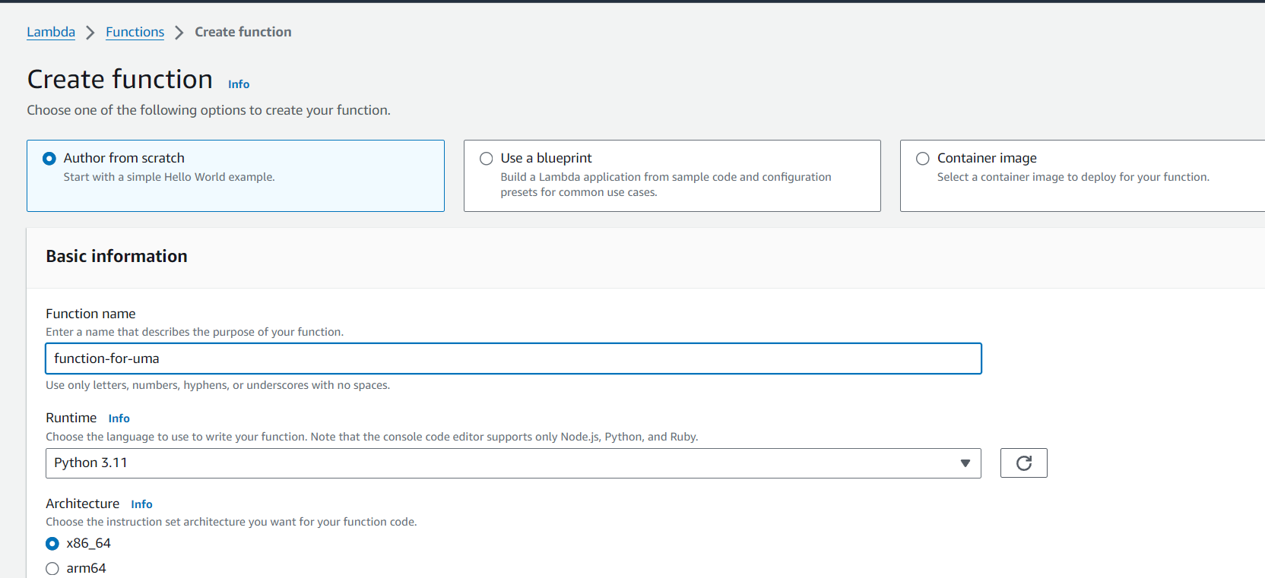

Next the function is this

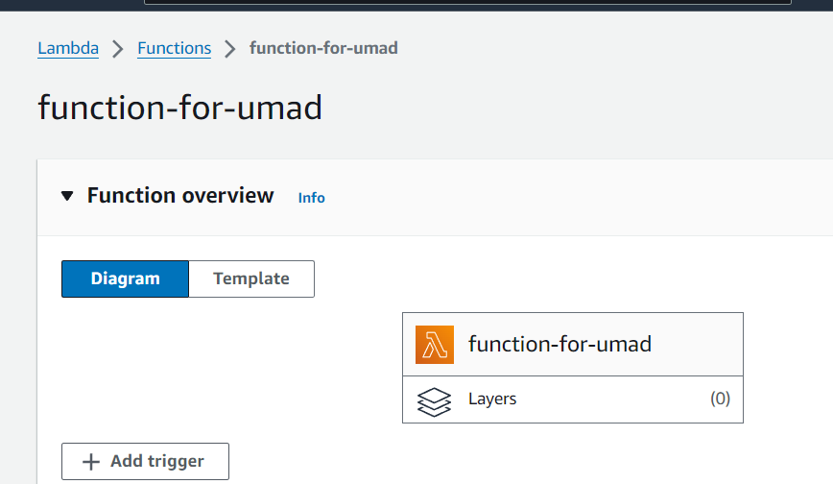

Now we will edit code part of function as per requirement after editing pasted below

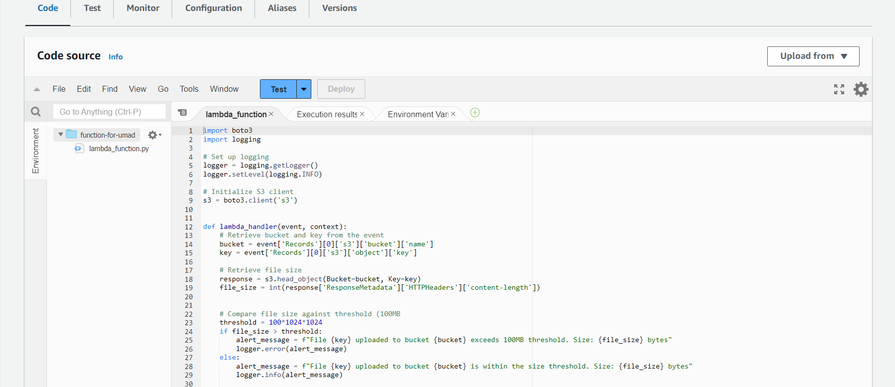

● S3 to Lambda Integration ○ Configure the previously created S3 bucket to trigger the Lambda function upon file uploads. Specify the event type as "All object create events.

Next we will add s3 bucket as trigger to this aws lambda function

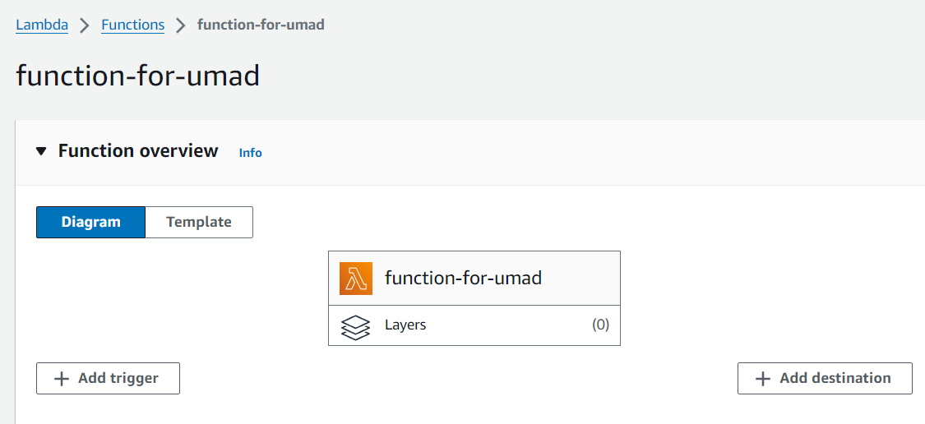

Add trigger next while adding select required trigger here it’s S3 and required bucket and event as all object create events other events are there but we not need them

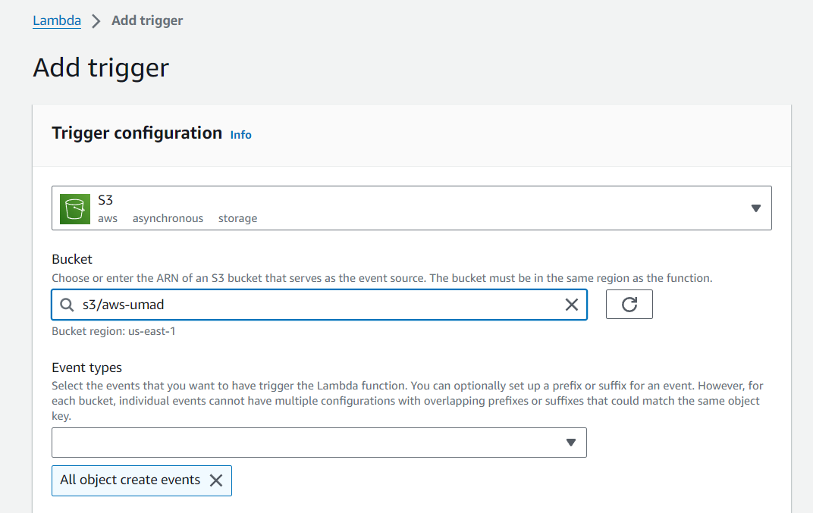

After adding it will look like below

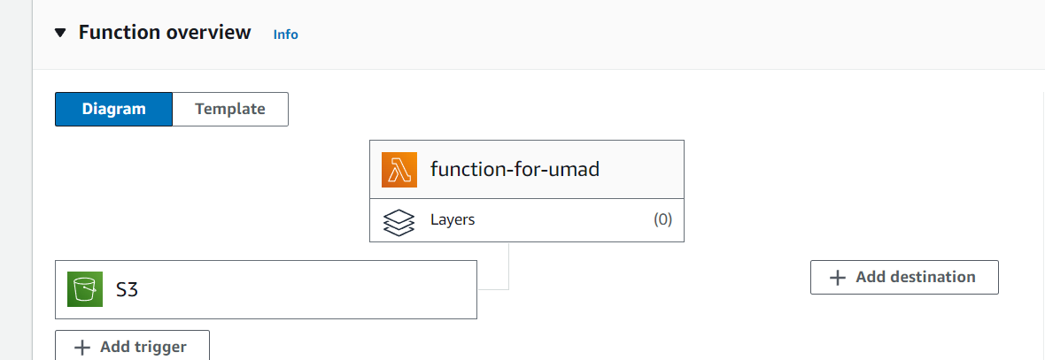

Next

● Testing and Validation ○ Test the Lambda function by uploading files of various sizes to the S3 bucket

Include tests for files smaller than 100MB and larger than 100MB. Grow Data Skills ○ Validate that the Lambda function executes as expected by reviewing the logs in Amazon CloudWatch. Ensure that an appropriate alert is logged for files exceeding the size threshold.

Next will upload a file in s3 bucket

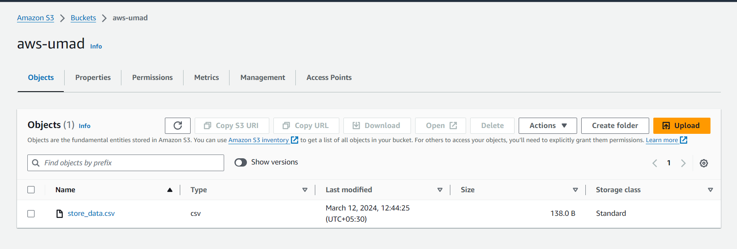

And create test event and it in event json we will replace required events like this

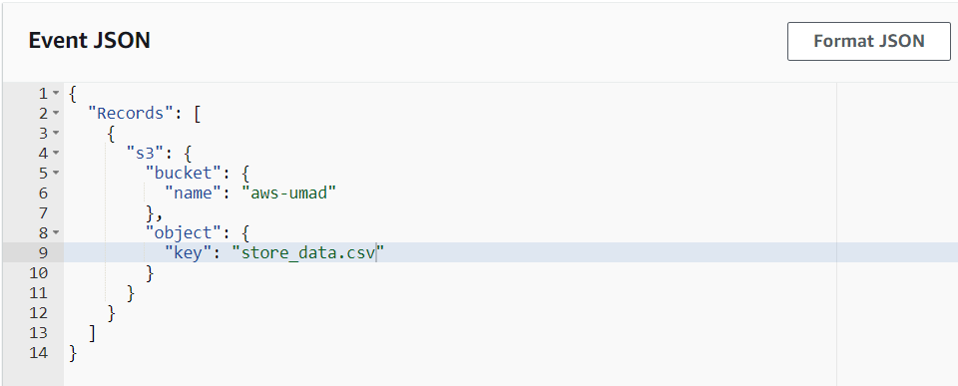

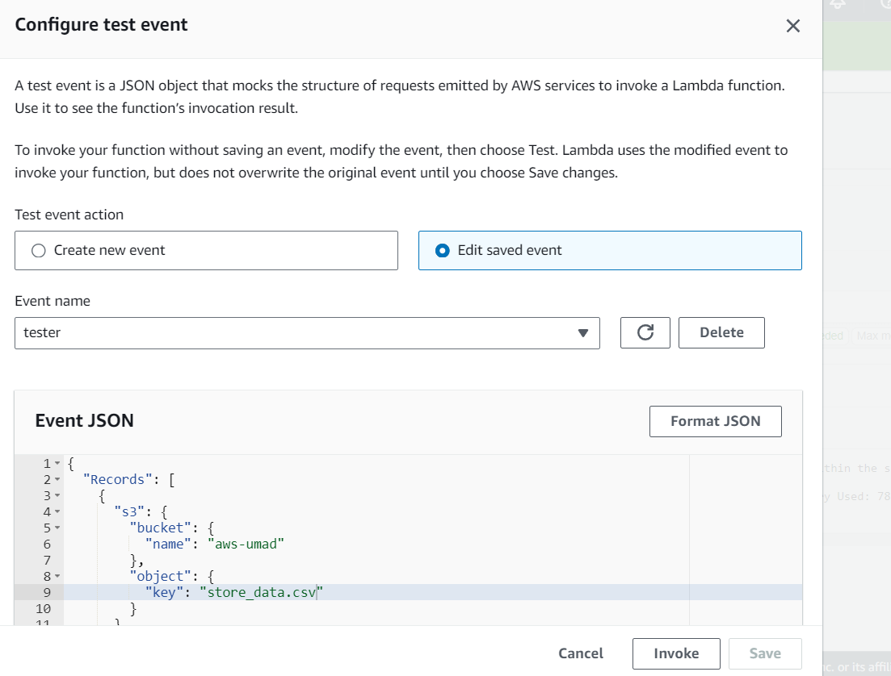

We will test and can see execution results and for outut we watch cloud watch logs

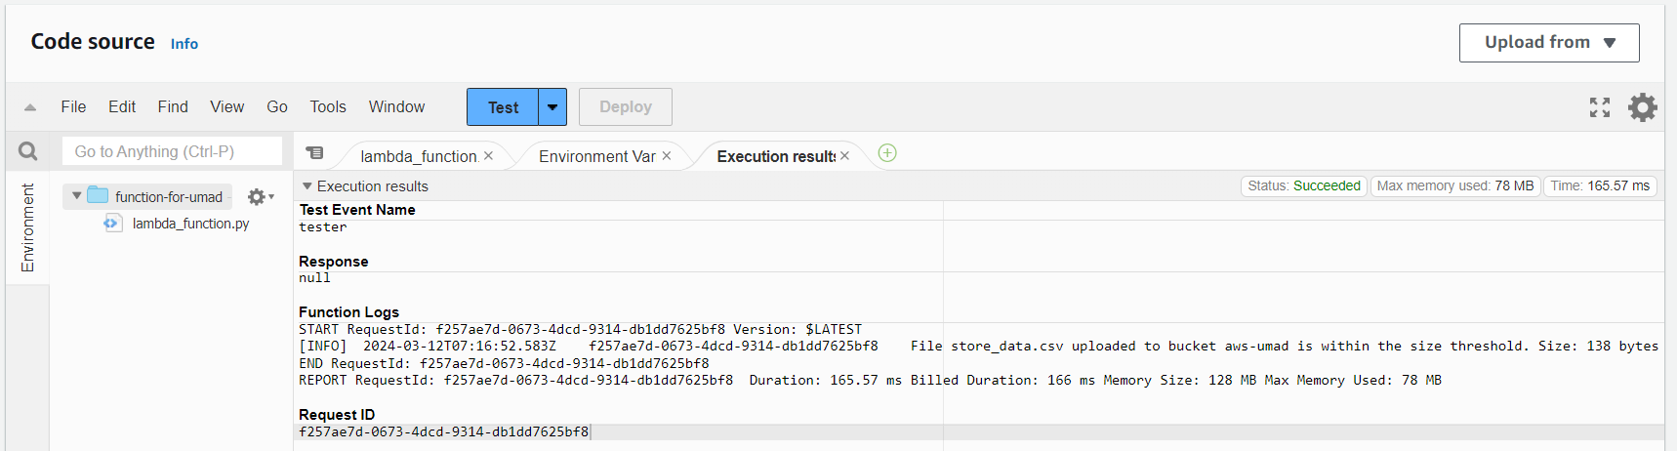

Click monitor -> here we see cloud watch metrics for invocations and duration other logs View next 🡪Click on View cloud watch logs -> logs

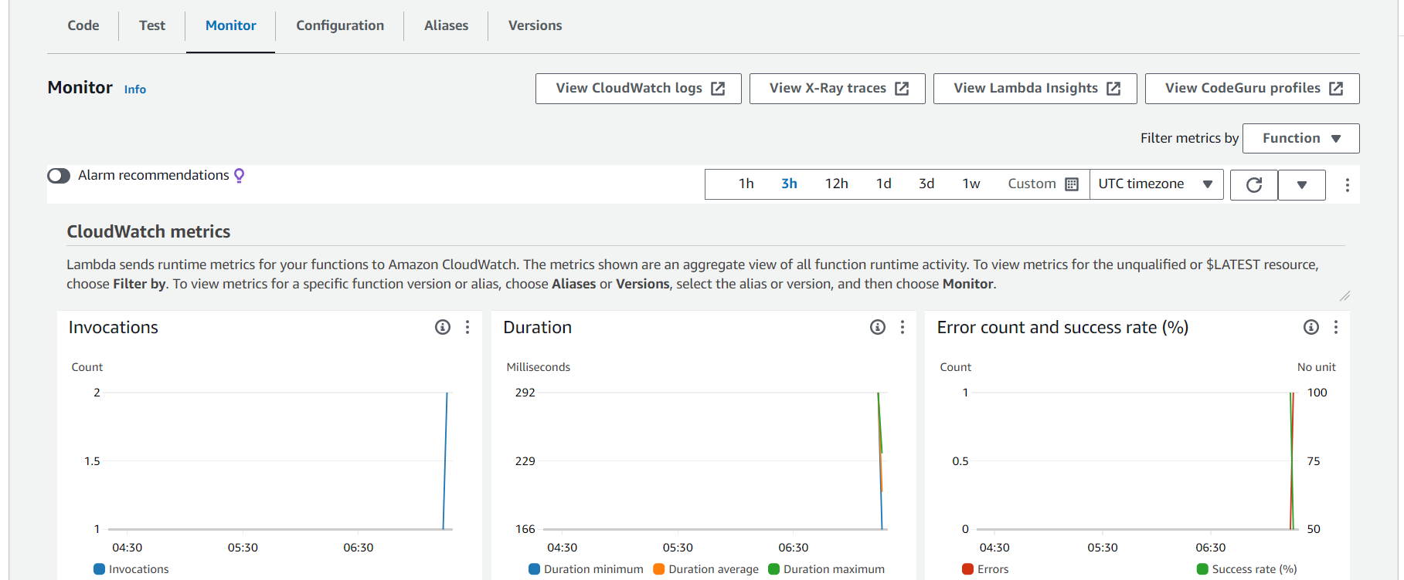

We can see log streams click on it

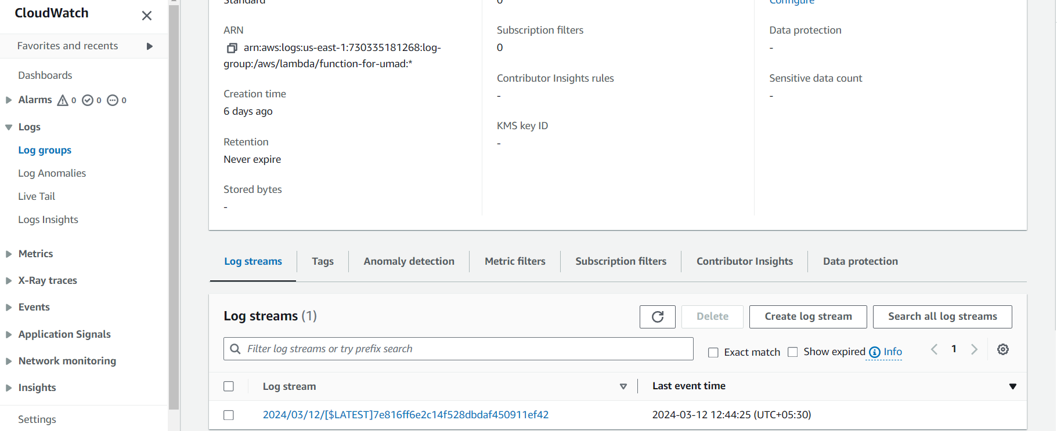

Here’s logs after clicking on it file size is within 100 MB

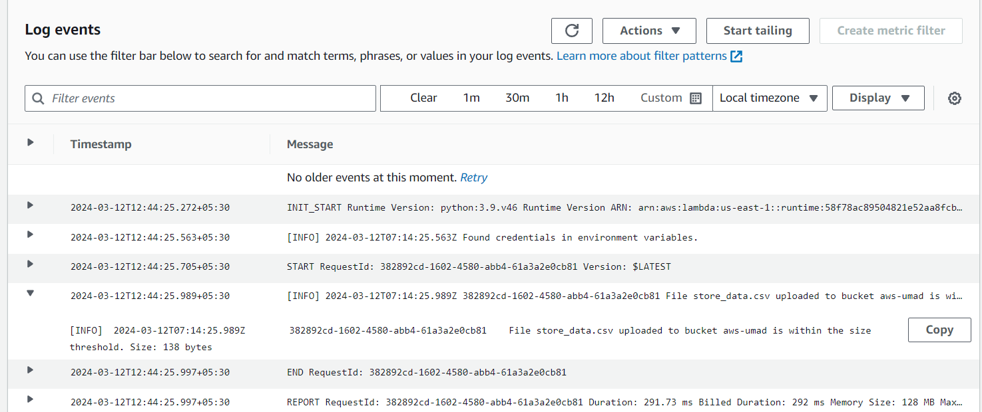

Now if we upload a file greater than 100MB it should give error because we had written the code to accept upto threshold value i.e100MB

We need to change event Json in Test event as below because here key should be changed according to file name

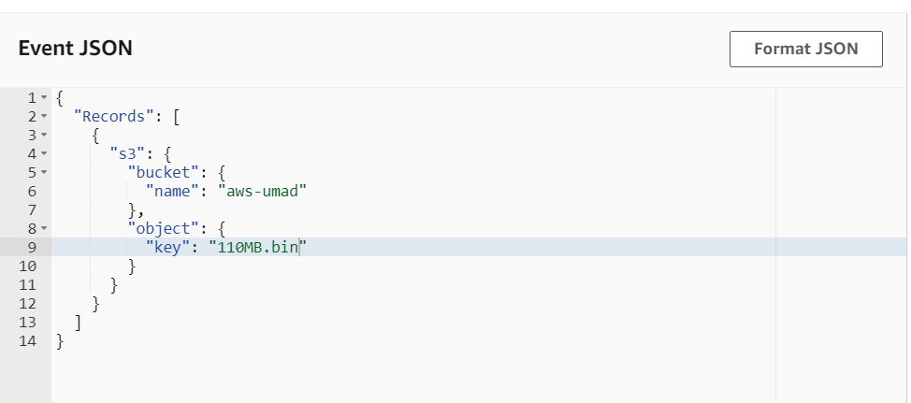

Then we can see execution results that shows

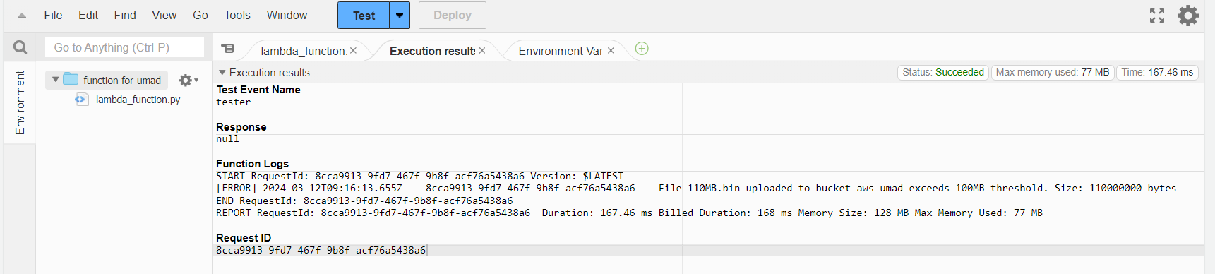

And log events

